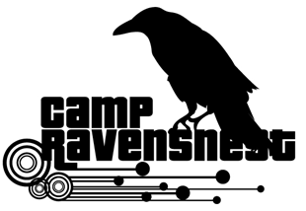
Junior Counselor Application 2020
Applicants for this volunteer/non-paid position are required to be at least rising 7th graders.

Availability for training: (You must attend one session. Please check one.)
___ June 12 (Friday)^{h} 10:00 am–4:00 pm (Set-Up & Training Day)
___ June 13 (Saturday) 10:00 am– 2:00 pm (Set-Up & Training Day)
(Training will be required before you may begin working)

Work availability: (Please check all that apply)
Week 1____June 15 - 19
Week 2___ June 22 - 26
We are closed week of June 29 – July 3
Week 3___ July 6 - 10
Week 4___ July 13 - 17
Week 5___ July 20 - 24
Week 6___ July 27 - 31
Week 7___ August 3 - 7

Shift(s) available:
___ Can work either shift (7AM-12PM or 12PM-5PM)
___ Can work only AM shift (7AM-12PM)
___ Can work only PM shift (12PM-5PM)

Name: _______________________________________________
Email: _______________________________________________
Home Phone: _________________________________________
Cell Phone: _________________________________________
Address: _____________________________________________
City, State: _________________________, _________ ZIP _______________
Age: ________ Birthday: _______________________ T-shirt Size: ___________

Please check one:
___Middle School Student School Name _________________________ Grade: ______

___High School Student School Name __________________________Grade:_____

Other: _______________________________________________________________________

(*) Please answer the following questions: (see back page). Thank you.

- Explain why you are applying for this position?

- What experiences have you had that would enable you to be a good junior camp counselor?

- Have you had any previous summer camp experience(s) working with children ages 5-11?

- What leadership positions have you held in your school or community?

- What hobbies, activities or interests do you have that might help you as a camp counselor?

- Why do you think you are a good candidate for this position?

REFERENCES:
Please give us at least 3 (three) names of people who can vouch for you. (Could be a teacher, a coach, or a community family friend).
Name | Relation to candidate | Tel(s) numbers

Employees will be selected based on experience, recommendations and application answers.

Applications will be accepted up from February 15 to March 15, 2020.

(Important: Applications received after 3/15/20 will not be considered for employment)

Your application status will be emailed to you by mid-April, 2020.

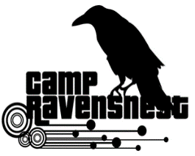
Please return applications inside a sealed envelope to:
RavensNest Summer Program, Attn. Mr. Sandy Kapatos
7409 Falls of Neuse Rd. Raleigh, NC 27615

