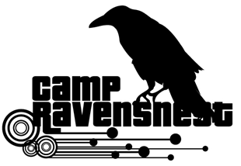
LEAD Counselor Application 2021
Applicants for this position are required to be at least 18 years old, have completed at least one year of college and had prior child care experience of at least 4 (four) years.

Main Responsibilities:
● Primary supervision of campers
● Prepare lesson plans and daily implementation of activities and games
● Provide campers with a fun and safe environment
● Clean and maintain camp spaces
● Provide daily communication with parents and staff

Availability for training: (You must attend one session. Please check one.)
___ June 11 (Friday)^{h} 10:00 am–4:00 pm (Set-Up & Training Day)
___ June 12 (Saturday) 10:00 am– 2:00 pm (Set-Up & Training Day)
(Training will be required before you may begin working)

Work availability: (Please check all that apply)
Week 1____June 14 - 18
Week 2___ June 21 - 25
We are closed week of June 28 – July 2
Week 3___ July 5 - 9
Week 4___ July 12 - 16
Week 5___ July 19 - 23
Week 6___ July 26 - 30
Week 7___ August 2 - 6

Shift(s) available:
___ Can work either shift (7AM-12PM or 12PM-5PM)
___ Can work only AM shift (7AM-12PM)
___ Can work only PM shift (12PM-5PM)

Name: _______________________________________________
Email: _______________________________________________
Home Phone: _________________________________________
Cell Phone: _________________________________________
Address: _____________________________________________
City, State: _________________________, _________ ZIP _______________
Age: ________ Birthday: _______________________ T-shirt Size: ___________

Please check one:
___Middle School Student School Name _________________________ Grade: ______

___High School Student School Name __________________________Grade:_____

Other: _______________________________________________________________________

(*) Please answer the following questions: (see back page). Thank you.

- Explain why you are applying for this position?

- What experiences have you had that would enable you to be a good junior camp counselor?

- Have you had any previous summer camp experience(s) working with children ages 5-11?

- What leadership positions have you held in your school or community?

- What hobbies, activities or interests do you have that might help you as a camp counselor?

- Why do you think you are a good candidate for this position?

REFERENCES:
Please give us at least 3 (three) names of people who can vouch for you. (Could be a teacher, a coach, or a community family friend).
Name | Relation to candidate | Tel(s) numbers

Employees will be selected based on experience, recommendations and application answers.

Applications will be accepted up from February 15 to March 15, 2021.

(Important: Applications received after 3/15/21 will not be considered for employment)

Your application status will be emailed to you by mid-April, 2021.

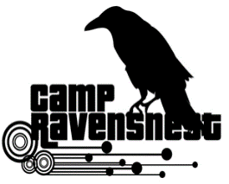
Please return applications inside a sealed envelope to:
RavensNest Summer Program, Attn. Mr. Sandy Kapatos
7409 Falls of Neuse Rd. Raleigh, NC 27615

