

# *Ravensnest*

# *Summer Camp*

**Ravensnest Summer Program 2021**

### Ravensnest

### Summer Camp

**Ravensnest Summer Camp** is a camp for rising Kindergarteners to rising 6th graders. We seek to provide campers with a safe, fun, and enriching summer experience.

We would like to welcome back our returning families and extend warm greetings to the new families who are joining us for the first time this summer!

We are excited that you have chosen to enroll your child(ren) in **Ravensnest** this summer, and we are looking forward to a fun filled summer camp experience with them!

**Let the good times roll!**



|  |  |  |  |  |
| --- | --- | --- | --- | --- |
| **Mondays**  **“Amazing Animals”** | **Tuesdays**  **“Science Adventures”** | **SPECIAL**  **WEDNESDAYS**  **Grinning face outline with solid fill** | **Thursdays**  **“Around the World”** | **Fridays**  **All about**  **WATER** |
|  |  | **Week 1:**  **Virtual Zoo** |  |  |
|  |  | **Week 2:**  **A Bug’s Life**  **Nature Walk** |  |  |
|  | https://openclipart.org/image/800px/svg_to_png/192590/1396998431.png | **Week 3:**  **Dinosaurs’**  **Day** |  |  |
|  |  | **Week 4:**  **Movie & Pizza Day** |  |  |
|  | https://openclipart.org/image/800px/svg_to_png/192590/1396998431.png | **Week 5:**  **Wizards & Magic Day** |  |  |
|  |  | **Week 6:**  **Dress like a Superhero day** |  |  |
|  | https://openclipart.org/image/800px/svg_to_png/192590/1396998431.png | **Week 7:**  **Kona Ice**  **Party** |  |  |
|  |  |  |  |  |

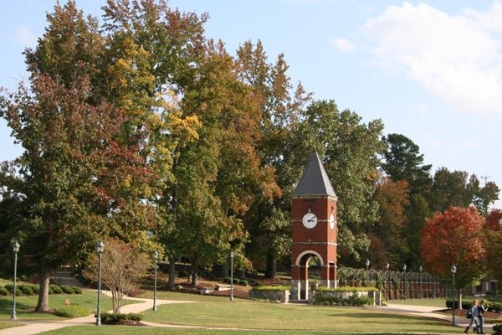







**Seven weeks of fun!**

**June 14th – August 6th, 2021.**

**Welcome campers!**







**Ravenscroft School**

**7409 Falls of Neuse Rd.**

**Raleigh, NC 27615**

**Tel. (919) 847-0900**

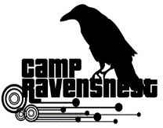

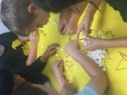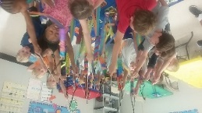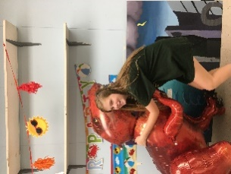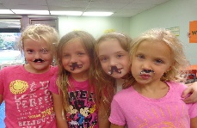

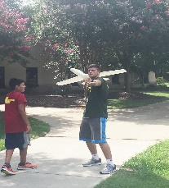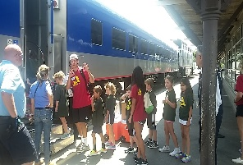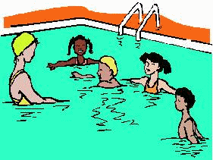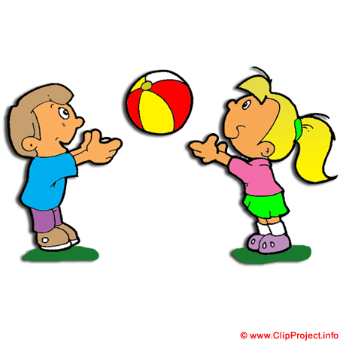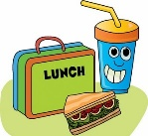

***Ravensnest Summer Camp***

Phone: **919-847-0900**

***Whitneye McCoy Leana R. Stewart***

***Summer Camp Director Coordinator***

[whitneye.mcoy@ravenscroft.org](mailto:whitneye.mcoy@ravenscroft.org) [senorastewart@yahoo.com](mailto:senorastewart@yahoo.com)

***Sandy Kapatos***

***Ravenscroft Director Auxiliary Services***

[sandy.kapatos@ravenscroft.org](mailto:sandy.kapatos@ravenscroft.org)

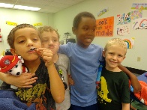



* **Allergies/Food Restrictions** – If your child is allergic or has any food/dietary restrictions, please make a note of it at the time of registration. If our summer camp menu presents a problem for your child, we recommend he/she brings a packed lunch and snacks from home.
* **Medicines** – We ***cannot*** administer any medications to the campers, except an epipen.
* **Camp Groups** – Ravensnest is divided into three separate age groups throughout the summer: **Yellow Ducks** (**\***Rising K-1st grade) **Blue Dolphins** (Rising 2nd -3rd grade) and **Red Dragons** (Rising 4th-6th grade). These will be the groups that campers will conduct their daily activities with.
* **What to bring to the camp**:

– Campers are to wear closed toed shoes *(sneakers or crocs)* each day. No flip flops or sandals are allowed**.**

- Campers must bring an extra set of clothes at the beginning of each week with his/her name on each item, placed in a labeled plastic bag, and inside a backpack. If your child is in the Yellow Ducks Group, a labeled double flat sheet will be needed for personal quiet/rest time. *The sheet will need to be brought home each day for washing.*

- According to the new CDC guidelines, every

camper ***must wear mask***, and are ***not*** *to bring any stuffed animals, toys, books, or electronic gadget from home.*

* For additional information, please check our school website or speak with one of the administrators.

***Daily Schedule Sample***

|  |  |  |  |
| --- | --- | --- | --- |
| Time | **Yellow Ducks** | **Blue Dolphins** | **Red Dragons** |
| 7:00 – 8:15 | Drop off  Arrival time | Drop off  Arrival time | Drop off  Arrival time |
| 8:15 – 9:15 | Clean-up & Get set  Announcements  Let’s Stretch! | Clean-up & Get set  Announcements  Let’s Stretch! | Clean-up & Get set  Announcements  Let’s Stretch! |
| 9:15–10:00 | Playground | GYM | Field Playtime |
| 10:00–10:30 | Snacks  (room) | Snacks  (Center) | Snacks  (room) |
| 10:30-11:00 | Break/Transition  Health/Safety Guidelines | Break/Transition  Health/Safety Guidelines | Break/Transition  Health/Safety Guidelines |
| 11:00-12:00 | Themed Activity | Themed Activity | Themed Activity |
| 12:00–12:45 | **LUNCH**  (center) | M&M and Games  (room) | GYM |
| 12:45 – 1:30 | Story Time  Quiet Time | **LUNCH**  (room) | **LUNCH**  (center) |
| 1:30 – 2:15 | Nap Time | Quiet Room Activities | Quiet Room Activities |
| 2:15 – 3:00 | Gym Games | Playground | Outside Play |
| 3:00 – 3:30 | SNACKS  (center) | SNACKS  (room) | SNACKS  (room) |
| 3:30 – 4:15 | Arts and Crafts  Trivia Games | Arts and Crafts  Trivia Games | Arts and Crafts  Trivia Games |
| 4:15 – 5:00 | Music, Dance and  Skits | Lego Challenge &  Building Competition | Playground  Outside Games |
| 5:00 – 6:00 | Clean up/Get Organized  Board Games  Pick-up | Clean up/Get Organized  Board Games  Pick up | Clean up/Get Organized  Board Games  Pick up |



## Ravensnest Camp

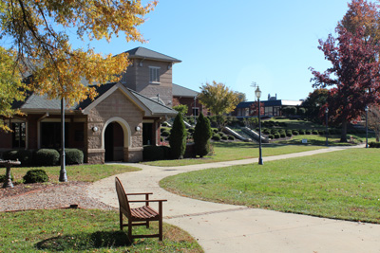

The mission of camp **Ravensnest** is to provide a safe and fun environment for our campers. That way, campers can focus on fostering new friendship and enjoying the exciting activities and adventures in store for them this summer.

**Parent Information – *Please read carefully!***

* **Pick Up/Drop Off** – Ravensnest opens at 7am and closes at 6pm. Please make sure you *pick up your child/children on time.*
* Upon arriving at Ravensnest, you must sign your child/children in on the proper clipboard at the reception desk outside and write any pertinent information that staff needs to know regarding your child for that day. When you pick up your child/children, please present your picture ID to the staff member and sign out before departing. ***Additionally, if someone else will be picking up your child that day or you will be picking up your child earlier, we ask that you enter that information in the “Notes” section of the clipboard during morning drop off.***
* **Snacks/Lunch** – As part of the camp fee your child is served lunch and two nutritious snacks daily. ***Campers with food restriction or allergy are encouraged to bring their own lunch and snacks*** (pls make sure this food does not need refrigeration).
* Every camper must have all their belonging in a backpack with his/her name on an ID tag.
* Please make sure you pack a water bottle in your child’s backpack so that they can stay hydrated throughout the day.



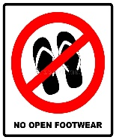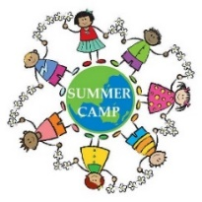

**Reminder:** Each camper must have:

Backpack + water bottle + ID tag + mask

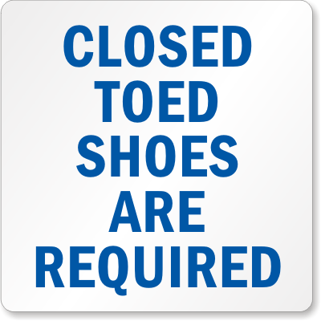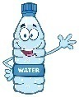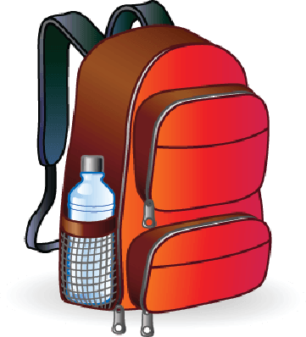

See the source image

 ***(*) Yellow Ducks starting age must be 5 years old.***