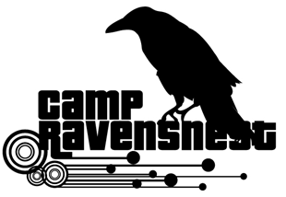
Assistant Counselor Application 2021
Applicants for this position are required to be at least 16 years old by 06/10/21, and had prior child care experience of at least 3 (three) years.

Main Responsibilities:
● Assist Lead Counselor with supervision of all campers
● Support Lead Counselor with set-up and administration of daily games and activities
● Help promoting a fun, healthy and safe environment
● Help/assist Lead Counselor to clean and maintain camp spaces
● Help/assist Lead Counselor with daily communication and children discipline and schedule

Availability for training: (You must attend one session. Please check one.)
___ June 11 (Friday)^{h} 10:00 am–4:00 pm (Set-Up & Training Day)
___ June 12 (Saturday) 10:00 am– 2:00 pm (Set-Up & Training Day)
(Training will be required before you may begin working)

Work availability: (Please check all that apply)
Week 1____June 14 - 18
Week 2___ June 21 - 25
We are closed week of June 28 – July 2
Week 3___ July 5 - 9
Week 4___ July 12 - 16
Week 5___ July 19 - 23
Week 6___ July 26 - 30
Week 7___ August 2 - 6

Shift(s) available:
___ Can work either shift (7AM-12PM or 12PM-5PM)
___ Can work only AM shift (7AM-12PM)
___ Can work only PM shift (12PM-5PM)

Name: _______________________________________________
Email: _______________________________________________
Home Phone: _________________________________________
Cell Phone: _________________________________________
Address: _____________________________________________
City, State: _________________________, _________ ZIP _______________
Age: ________ Birthday: _______________________ T-shirt Size: ___________

Please check one:
___Middle School Student School Name _________________________ Grade: ______

___High School Student School Name __________________________Grade:_____

Other: _______________________________________________________________________

(*) Please answer the following questions: (see back page). Thank you.

- Explain why you are applying for this position?

- What experiences have you had that would enable you to be a good junior camp counselor?

- Have you had any previous summer camp experience(s) working with children ages 5-11?

- What leadership positions have you held in your school or community?

- What hobbies, activities or interests do you have that might help you as a camp counselor?

- Why do you think you are a good candidate for this position?

REFERENCES:
Please give us at least 3 (three) names of people who can vouch for you. (Could be a teacher, a coach, or a community family friend).
Name | Relation to candidate | Tel(s) numbers

Employees will be selected based on experience, recommendations and application answers.

Applications will be accepted up from February 15 to March 15, 2021.

(Important: Applications received after 3/15/21 will not be considered for employment)

Your application status will be emailed to you by mid-April, 2021.

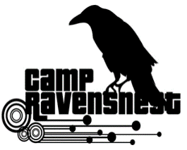
Please return applications inside a sealed envelope to:
RavensNest Summer Program, Attn. Mr. Sandy Kapatos
7409 Falls of Neuse Rd. Raleigh, NC 27615

